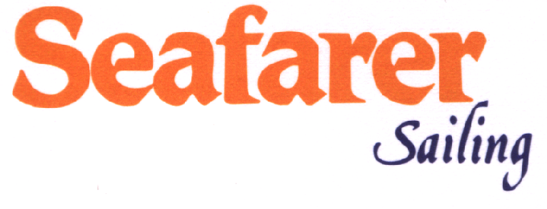

TERMS AND CONDITIONS OF CREWED YACHT CHARTER

- Booking procedure: After your client having selected a yacht, suitable dates and ports of embarkation/disembarkation, we will prepare a Memorandum of Agreement (MOA). This agreement will be sent to you in order to be signed and returned to us. In order to secure the yacht on your behalf, at this point, you should deposit 50% of the charter fee to our account (after deducting your commission ranging from 15% to 20% depending on the yacht). When the Owner countersigns the Agreement, one of the originals will be returned to you. The balance of the Charter Fee, the advance towards provisioning of the yacht (A.P.A.), the V.A.T. and any applicable delivery or redelivery fee will be due for payment to us one month prior to embarkation.

- Included/Excluded in the charter rates: Rates include the hire fee as well as the insurance of the yacht, professional crew fed and insured, ship’s laundry and water. Excluded are fuel for the yacht, tender and toys, all food and drinks, communication costs, personal laundry, canal dues, gratuity for the crew and V.A.T. Moreover if cruising outside Greek waters, advise your client that he is supposed to submit berthing dues and harbor charges including canal and pilotage fees as well as charges for the electricity and water taken from shore. Local taxes could be also charged to him.

- Advance Provisioning Allowance (A.P.A.): This guarantee deposit is used to cover all expenses not included in the charter rate (as mentioned above). Depending on the yacht, the provisioning requested by the Charterer, the number of passengers and the days of the cruise, the client will pay the respective amount. In general, everything included, the A.P.A. falls somewhere between 20%-30% of the charter fee. Full account is always produced at the end of the charter after deductions of costs charged to the Charterer are made. If refunds or any other kind of payment is due, the final account determines it. Kindly note that only cash payments are accepted.

- REPOSITIONING CHARGES: Most of the listed yachts are based in marinas lying in the vicinity of Athens. When a Yacht is requested to start or terminate a charter outside its homeport then a delivery and/or redelivery fee is negotiated and included in the agreement Clauses

- Insurance: Charterers are always been advised to consider cancellation and curtailment insurance. In addition Charterers may consider Medical and Personal Accident Insurance that is excluded from the charter fee.

- V.A.T: In accordance with the European Union Directive of January 1st 1993, yacht charter prices are subject to varying tax rates depending on the country or countries you visit during the charter. In Greece V.A.T. is applicable of 6,5 to 13% of the charter fee, depending on the cruising area and duration of charter

- Boat preparation : At least one month prior to embarkation, you are kindly requested to send us the appropriate details such as travel arrangements and flight details, passengers’ names, special preparations requested (as far as food or celebrations are concerned) etc. filled in corresponding forms, which you will be provided with.

- Itinerary: It is our pleasure to recommend your client an itinerary or even advise him/her of the best places to visit taking into consideration time availability. Due to weather conditions or any other unpredictable factors, itineraries should be kept flexible. The Captain’s decision should always be final regarding the safety of the passengers and the yacht according to the Safety of Life at Sea Regulations.

- Water sports: The majority of yachts carry a variety of sports equipment. Charterers can make use of the jet-skis (if available) with due consideration for the safety and tranquility of swimmers and other yachtsmen. Concerning independent scuba diving, charterers have to note that in Greece and Turkey severe control has been taken in order to curb or plunder any underwater antiquities. Therefore, they have to dive with local and licensed diving instructors.

- Gratuities: It is customary for charter party if they are pleased with the service on board, to leave a gratuity for the crew. The amount is left at client’s discretion; a figure within the range of 5%-15% on the charter fee is usual.

- Additional services : Our Company can make all travel arrangements including car rental, limousines, helicopters, hotel reservations, etc. as well as private visits and guided tours to ancient sites and monuments on the islands or inland.

NOTES:

- Please do let client know that most yachts offer special prices at low season bookings.

- For everybody’s safety, advise Charterer not to smoke in bed and to refrain from smoking when walking in passageways. Also, make sure cigars and cigarette butts are extinguished. Do not throw matches or cigarette butts overboard as they may be drawn into open portholes, windows, and ventilators.

TERMS AND CONDITIONS OF BAREBOAT CHARTER

- Charters usually commence on Saturday at 17:00 hours and end on Saturday at 09:00 hours (Friday 18:00 return to marina + overnight). Other days of the week may be possible upon request.

- Upon receipt of Booking Confirmation we will issue Charter Contract and send you the Invoice accordingly.

- Within 7 days from the date of confirmation we require advance payment of 50%, otherwise booking will be cancelled automatically.
One month before your departure we require full payment (plus skipper and hostess fees in case they are required) along with crew list & one (1) copy of Sailing License. Optional extras, reserved by client in advance, for any of our bases, are required to be paid upon embarkation in cash. If paid by credit cards, then surcharge of 3% will be required.

- Optional extras, reserved by client in advance, for any of our bases, are required to be paid upon embarkation in cash. This is the only accepted procedure. If paid by credit cards, then surcharge of 2%-3% (depending on the bank) will be required.

- Refundable Guarantee Deposit, as per our price list, will be collected by Seafarer Base Manager via credit card upon embarkation. Instead of Refundable, you can choose the Non Refundable Guarantee Deposit which can insure totally the yacht as well.
VISA, MASTERCARD, DINERS CLUB & AMERICAN EXPRESS is accepted in all bases.
Guarantee Deposit is also required, even if a skipper is hired at extra cost.
Either way of Guarantee Deposit you may choose, you must inform Seafarer one week before embarkation.

- Cancellation fees are calculated depending on the period of time between the date of cancellation and the departure date as follows:
More than 60 days before embarkation, 30% to the total charter fee.
Between 60-30 days before embarkation, 50% to the total charter amount.
Less than 30 days before embarkation, 100% to the total charter amount.

Seafarer Sailing will return the cancellation fees, less dossier fees 250€, if the cancelled yacht is rebooked for the same period under the same conditions.

- Claims are negotiable maximum within 14 days from the end of the charter provided that the client has contact the Base to mention the any problem during his Charter. Otherwise no claim will be accepted.

- Transfers, Food provisioning or any optional extras, such as Hotel Reservations – Car Rental –Flight /Ferry Tickets can be arranged upon request. Food List is available.

NOTES:
- Please read carefully the terms and conditions of Bareboat Charter Contract. These terms cannot be modified.
- Make sure that you understand what equipment is included in the price of yacht chosen.
- The yacht is delivered full of fuel and water and should be redelivered the same prior your disembarkation, at the end of your charter.
- Original copies of contract will be signed before embarkation, together with crew list copies, to obtain Port Police permission.
- Payments can be also made via credit card with surcharge of for bank expenses 1,9% for VISA, 2% for MASTERCARD, 2,9% for DINERS CLUB & 3,5% for AMERICAN EXPRESS.

