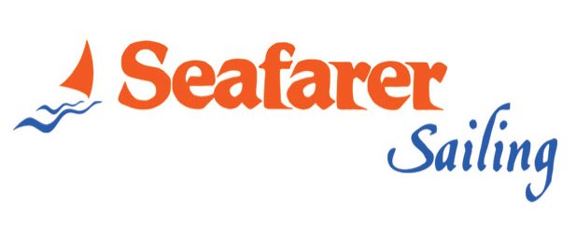
2017 SEASON
TERMS AND CONDITIONS OF BAREBOAT CHARTER

- Charters usually commence on Saturday at 17:00 hours and end on Saturday at 09:00 hours (Friday up to 17:00 return to marina & overnight). Other days of the week are possible upon request.

- Upon receipt of Booking Confirmation we will issue a Charter Contract and send it to you accordingly.

- Within 7 days from the date of confirmation we require advance payment of 50%, otherwise booking will be cancelled automatically.
One month before your departure we require full payment (plus skipper and hostess fees in case they are required) along with crew list & one (1) copy of Sailing License. Optional extras, reserved by client in advance, for any of our bases, are required to be paid upon embarkation in cash. If paid by credit cards, then surcharge 1,4%-3,5% (depending on the bank) will be required.

- Refundable Guarantee Deposit, as per our price list, will be collected by Seafarer Base Manager via credit card upon embarkation. Instead of Refundable, you can choose the Non Refundable Guarantee Deposit which can insure totally the yacht as well.
VISA, MASTERCARD, DINERS CLUB & AMERICAN EXPRESS is accepted in all bases.
Guarantee Deposit is also required, even if a skipper is hired at extra cost.
Either way of Guarantee Deposit you may choose, you must inform Seafarer one week before embarkation.

- Cancellation fees are calculated depending on the period of time between the date of cancellation and the departure date as follows:
More than 60 days before embarkation, 30% to the total charter fee.
Between 60-30 days before embarkation, 50% to the total charter amount.
Less than 30 days before embarkation, 100% to the total charter amount.

- Seafarer sailing will return the cancellation fees, less 3%, if the cancelled yacht is rebooked for the same period under the same conditions.

- Claims are negotiable maximum within 14 days from the end of the charter provided that the client contacts the base to mention the any problem during his charter. Otherwise no claim will be accepted.

- Transfers, Food provisioning or any other optional extras, such as Hotel Reservations, Wi-Fi, Car Rental, Flight /Ferry Tickets can also be arranged upon request. Provision List is available.
The above can be reserved in advance, for all our bases, are required to be paid upon embarkation in cash. If paid by credit cards, then surcharge of 1,4%-3,5% (depending on the bank) will be required.

NOTES:
- Please read carefully the terms and conditions of Bareboat Charter Contract. These terms cannot be modified.
- Make sure that you understand what equipment is included in the price of yacht chosen.
- The yacht is delivered full of fuel and water and should be redelivered the same prior your disembarkation, at the end of your charter.
- Original copies of contract will be signed before embarkation, together with crew list copies, to obtain Port Police permission.

PAYMENTS TO BE MADE:
- ALPHA BANK:
George Orphanos -Seafarer Sailing Ltd.
155 branch Eden Mare, Greece, Poseidon’s Ave. 73, 17562, Swift code: CRBAGRAAXXX
IBAN : GR 52 0140 1550 1890 0200 2001 406 or
- EUROBANK:
George Orphanos -Seafarer Sailing Ltd.
Branch 0142 Kalamakiou, Greece,
IBAN : GR 12 0260 1420 0009 7020 0440 109 or
- ERSTE BANK AUSTRIA :
George Orphanos, BLZ 20111 /WIEN 1130, Swift code: GIBAATWWXXX
EUR IBAN a/c AT 3820 1112 9543 809 400

- Payments can be also made via credit card with surcharge of for bank expenses 1,4% for VISA, 1,4% for MASTERCARD, 2,9% for DINERS CLUB & 3,5% for AMERICAN EXPRESS.

